ONEWAY ACC BY RES
/STATISTICS DESCRIPTIVES HOMOGENEITY WELCH
/PLOT MEANS
/MISSING ANALYSIS.

Oneway

Notes
Output Created |  | 06-May-2019 00:05:06
Comments
Input | Active Dataset | DataSet0
Input | Filter | <none>
Input | Weight | <none>
Input | Split File | <none>
Input | N of Rows in Working Data File | 30
Missing Value Handling | Definition of Missing | User-defined missing values are treated as missing.
Missing Value Handling | Cases Used | Statistics for each analysis are based on cases with no missing data for any variable in the analysis.
Syntax |  | ONEWAY ACC BY RES  /STATISTICS DESCRIPTIVES HOMOGENEITY WELCH  /PLOT MEANS  /MISSING ANALYSIS.
Resources | Processor Time | 00 00:00:00.172
Resources | Elapsed Time | 00 00:00:00.166

[DataSet0]

Descriptives
 | N | Mean | Std. Deviation | Std. Error | 95% Confidence Interval for Mean
 |  |  |  |  | Lower Bound | Upper Bound
1360x768 | 7 | 89.1429 | 33.46356 | 12.64803 | 58.1942 | 120.0915
1920x1080 | 15 | 98.0000 | 24.79919 | 6.40312 | 84.2667 | 111.7333
800x600 | 8 | 93.8750 | 21.72186 | 7.67984 | 75.7151 | 112.0349
Total | 30 | 94.8333 | 25.60722 | 4.67522 | 85.2714 | 104.3952

Descriptives
 | Minimum | Maximum
1360x768 | 50.00 | 150.00
1920x1080 | 57.00 | 128.00
800x600 | 63.00 | 128.00
Total | 50.00 | 150.00

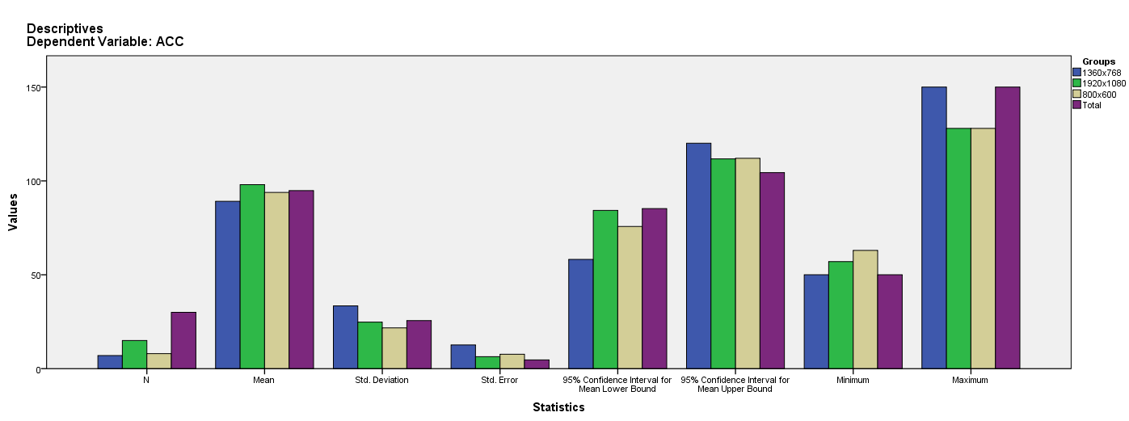

Test of Homogeneity of Variances
ACC
Levene Statistic | df1 | df2 | Sig.
1.279 | 2 | 27 | .295

ANOVA
ACC
 | Sum of Squares | df | Mean Square | F | Sig.
Between Groups | 384.435 | 2 | 192.217 | .279 | .759
Within Groups | 18631.732 | 27 | 690.064
Total | 19016.167 | 29

Robust Tests of Equality of Means
ACC
 | Statisticª | df1 | df2 | Sig.
Welch | .214 | 2 | 13.205 | .810
a. Asymptotically F distributed.

Means Plots

